Apple Appstore Analysis
Prepared by: Muhammad Ayyan Raffay
Tool Used: Python
Date: August 2026

Contents
1. Abstract 3
2. Introduction 3
3. Dataset Description 3
4. Objectives 3
5. Methodology 4
6. Analysis 4
6.1. Dataset Overview 4
6.2. Data Cleaning 5
7. Exploratory Data Analysis 5
7.1. Summary Statistics 5
7.2. Skewness and Kurtosis 6
8. Correlation Analysis 7
9. Regression Analysis 7
10. Statistical Analysis 9
10.1. Ipad by User Rating 9
10.2. Independent T-test 9
11. Outlier Analysis 9
12. Business Findings 10
12.1. Distribution of User Ratings 10
12.2. Distribution of Price 10
12.3. Free Vs Paid Apps 11
12.4. Top 10 Genre by User Ratings 12
12.5. App Popularity 12
13. Probability Distribution 13
13.1. Binomial Distribution 13
13.2. Success Vs Failure 13
14. Conclusion 14

- Abstract
This project analyzes an Apple App Store dataset to understand what factors are related to app ratings and popularity. The analysis uses EDA, data visualization, correlation, outlier analysis, regression, Business Findings, and Binomial Distribution to find meaningful patterns in the data. The main focus is to examine user ratings and explore whether factors such as price and supported devices are related to app performance.
- Introduction
The Apple App Store contains a large variety of applications with different prices, sizes, ratings, and features. This project analyzes App Store data to understand the patterns and factors that may influence user ratings and app popularity. Python is used to explore and visualize the data and apply statistical techniques such as correlation, regression, Chi-square, ANOVA, and Binomial Distribution. The aim is to turn the raw data into clear and useful insights about app performance and user satisfaction.
- Dataset Description
Apple App Store dataset including information about their size, price, ratings, supported devices, languages, and licensing.
id | A unique identification number assigned to each app.
Track_name | The name or title of the application.
size_bytes | The size of the application in bytes.
Currency | The currency used for the app's price, such as USD.
price | The price of the application in the App Store.
rating_count_tot | The total number of user ratings received by the app.
rating_count_ver | The number of user ratings received for the current version of the app.
user_rating | The overall user rating of the app, generally ranging from 0 to 5.
user_rating_ver | The user rating given specifically to the current version of the app.
Prime_genre | The primary genre or category assigned to the application, such as Games, Education, Business, or Music.
sup_devices.num | The number of devices supported by the application.
ipadSc_urls.num | The number of screenshots displayed for the app on the App Store.
lang.num | The number of languages supported by the application.
vpp_lic | Indicates whether the application supports Volume Purchase Program (VPP) licensing.

- Objectives
- To explore and understand the characteristics of apps available on the Apple App Store.
- To analyze user ratings and identify patterns in app performance and popularity.
- To visualize the data using different charts and graphs for better understanding.
- To identify and analyze outliers in important numerical variables.
- To examine relationships between numerical variables using correlation analysis.
- To determine whether supported devices can predict user ratings using linear regression.
- To apply Binomial Distribution to estimate the probability of highly rated apps.
- To draw meaningful insights from the analysis and summarize the overall findings.
- Methodology
The project was carried out using Python to analyze the Apple App Store dataset. First, the data was loaded and checked for missing values, duplicates, incorrect data types, and other errors. After confirming that the data was clean, Exploratory Data Analysis (EDA) was performed using descriptive statistics to understand the main characteristics of the dataset. Different visualizations, including histograms, boxplots, bar charts, and scatter plots, were used to identify patterns and relationships. Outlier analysis was performed using the IQR method. Correlation analysis was used to examine relationships between numerical variables. A t-test was used to compare user ratings between two groups and determine whether the difference was statistically significant. A simple linear regression was performed to investigate whether the number of supported devices could predict user ratings. Finally, Binomial Distribution was used by defining apps with ratings of 4 or above as successful outcomes. The results were then interpreted to identify meaningful insights from the dataset.
- Analysis
  - Dataset Overview
The dataset was first examined to understand its size, structure, columns, data types, missing values, and duplicate records. The first few rows were also inspected to understand the information available for each application. The dataset contains information about Apple App Store applications and includes both categorical and numerical variables. It provides details such as app name, size, price, ratings, supported devices, languages, screenshots, and genre. This initial examination helped determine the appropriate data cleaning, visualization, and statistical analysis methods for the project.
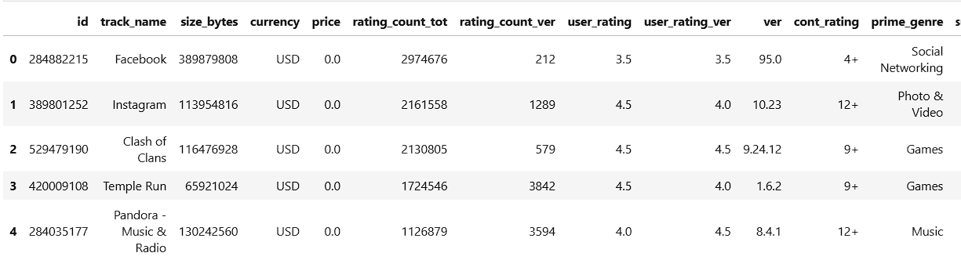
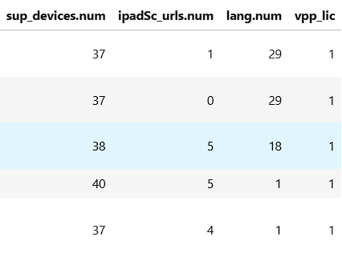
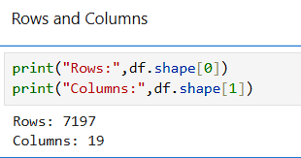
  - Data Cleaning
The dataset was checked to ensure that it was clean and suitable for further analysis. Missing values were checked across all columns, and no missing values were found. The dataset was also examined for duplicate records, and no duplicates were identified.
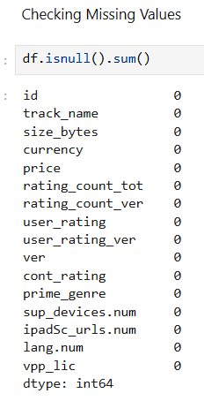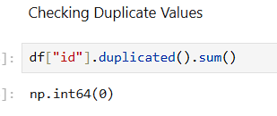
- Exploratory Data Analysis
  - Summary Statistics
Summary statistics were calculated for the numerical variables in the dataset, including price, app size, total rating count, current-version rating count, user rating, supported devices, and number of languages. Measures such as mean, median, minimum, maximum, and standard deviation were used to understand the distribution and general characteristics of the data.
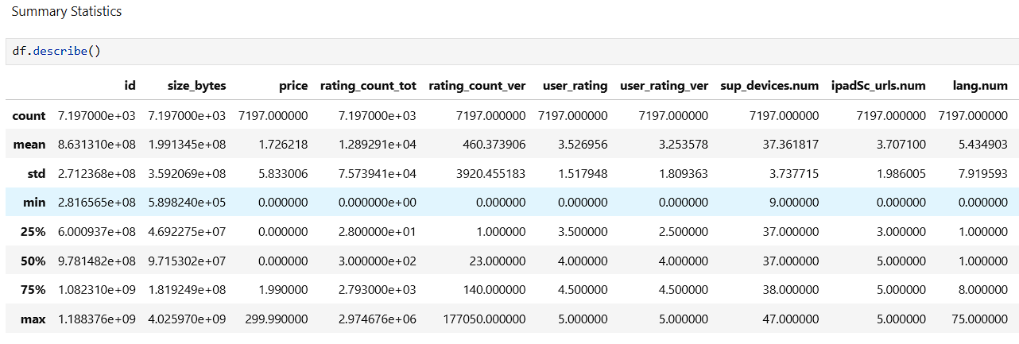
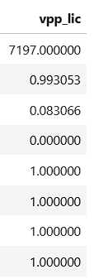
  - Skewness and Kurtosis
Skewness and kurtosis were calculated for the numerical variables to understand the shape and distribution of the data. Skewness was used to identify whether the variables were symmetrically distributed or affected by left or right skewness. Kurtosis was used to examine the presence of extreme values and the shape of the distributions. These measures helped provide a better understanding of the data before further statistical analysis.
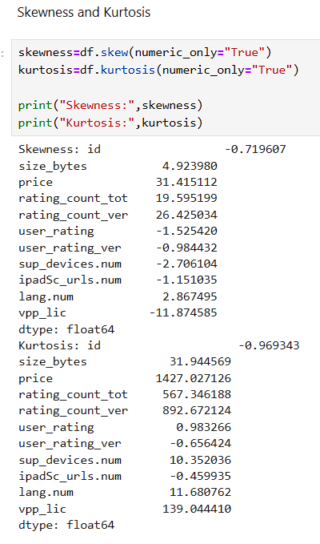
Skewness:
The results showed that several variables were highly skewed. The price variable had a very high positive skewness of 31.42, indicating that most apps have relatively low prices, while a small number of apps have much higher prices. Similarly, rating_count_tot (19.60) and rating_count_ver (26.43) were highly right-skewed, suggesting that a small number of apps received exceptionally large numbers of ratings. On the other hand, vpp_lic had strong negative skewness (-11.87), indicating a concentration of observations toward the higher end with a long left tail.
Kurtosis:
The kurtosis results also showed that some variables had heavy-tailed distributions. In particular, price had a kurtosis of 1427.03, while rating_count_tot and rating_count_ver had kurtosis values of 567.35 and 892.67, respectively. These high values indicate the presence of extreme observations and highly non-normal distributions. size_bytes also showed considerable positive skewness (4.92) and kurtosis (31.94).
- Correlation Analysis
Correlation analysis was performed to examine the strength and direction of relationships between the numerical variables in the dataset.
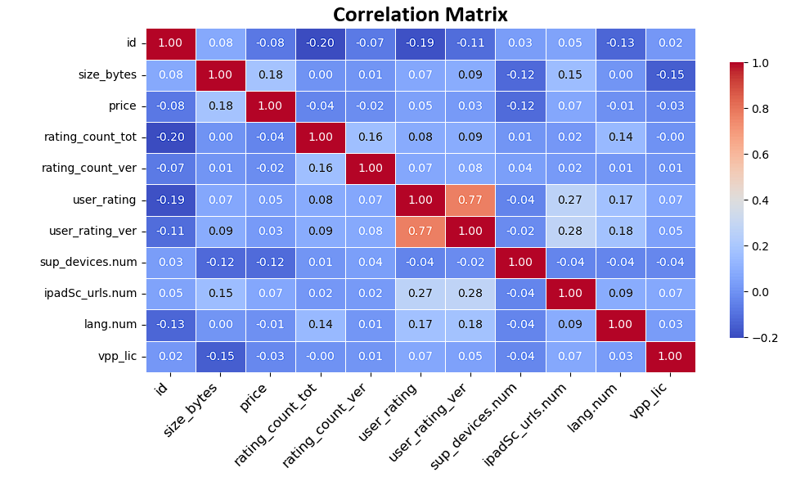
The correlation matrix was used to examine the relationships between the numerical variables. Most variables show weak or negligible correlations, indicating limited linear relationships among them. The strongest relationship is observed between user_rating and user_rating_ver, with a correlation coefficient of 0.77, indicating a strong positive relationship. Weak positive relationships are also observed between user_rating and ipadSc_urls.num (0.27) and between user_rating_ver and ipadSc_urls.num (0.28). Overall, the results show that most variables have little linear association, while the two user-rating variables demonstrate a comparatively strong relationship.
- Regression Analysis
A simple linear regression analysis was performed to investigate whether the number of supported devices (sup_devices.num) can predict the user rating (user_rating) of an application. In this analysis, sup_devices.num was used as the independent variable, while user_rating was used as the dependent variable. The regression model was used to determine the direction and strength of the relationship and to evaluate how much variation in user ratings can be explained by the number of supported devices.
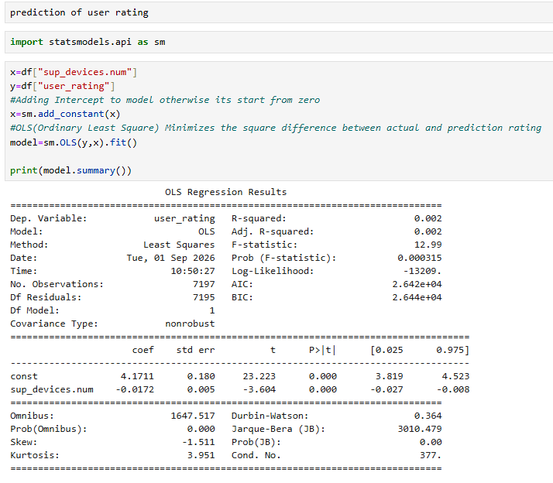
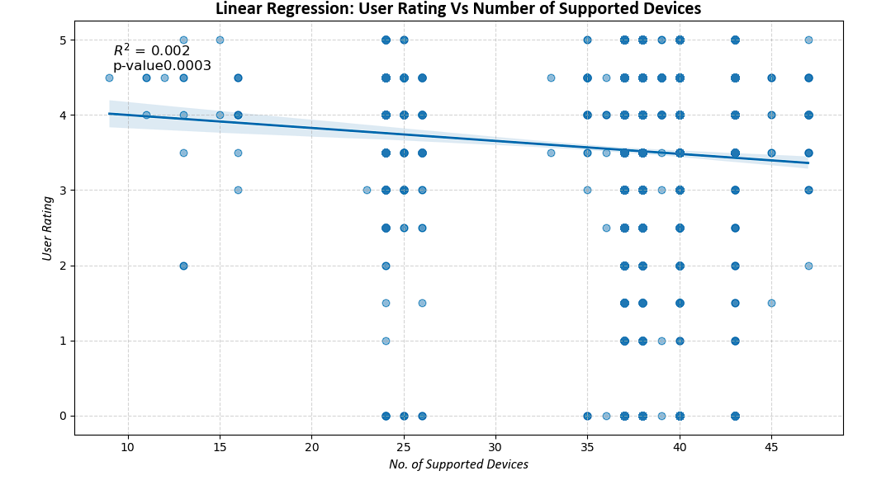
The regression line shows a slight negative relationship. The R² value of 0.002 indicates that the number of supported devices explains only 0.2% of the variation in user ratings. Although the p-value of 0.003 is statistically significant at the 5% significance level, the very low R² indicates that the relationship has little practical significance. Therefore, the number of supported devices is not a strong predictor of user ratings.
- Statistical Analysis
  - Ipad by User Rating
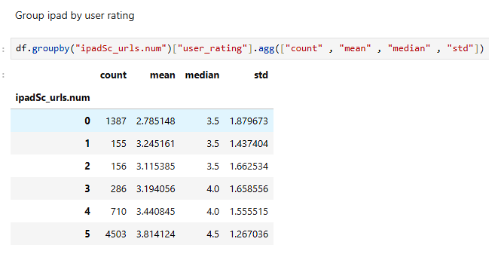
The descriptive statistics show a positive relationship between the number of iPad screenshot URLs and user ratings. The mean rating increased from 2.79 for 0 URLs to 3.81 for 5 URLs. Overall, observations with more iPad screenshot URLs tend to have higher user ratings.
  - Independent T-test
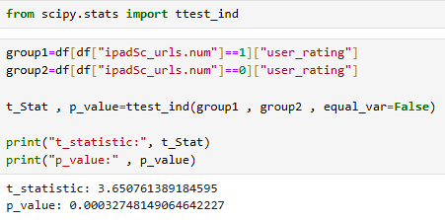
The t-test compared user ratings for observations with 0 and 1 iPad screenshot URLs. The 1-URL group had a higher mean rating (M = 3.25) than the 0-URL group (M = 2.79). The difference was statistically significant (t = 3.65, p < .001), indicating that user ratings differ significantly between the two groups.
- Outlier Analysis
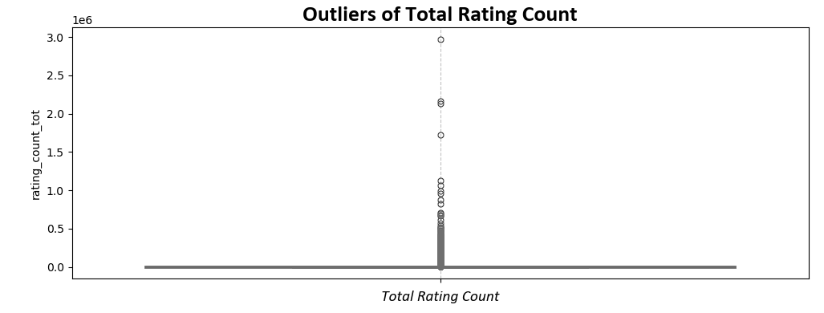

The boxplot shows that rating_count_tot contains a large number of outliers. Most apps have relatively low numbers of total ratings, while a small number of apps have received exceptionally high numbers of ratings. This indicates a strong right-skewed distribution, where a few highly popular apps receive substantially more ratings than the majority. These outliers are considered genuine observations rather than data-entry errors, as they represent apps with unusually high levels of popularity. Therefore, the outliers were retained in the dataset because they provide meaningful information about the popularity and user engagement of successful apps.
- Business Findings
  - Distribution of User Ratings
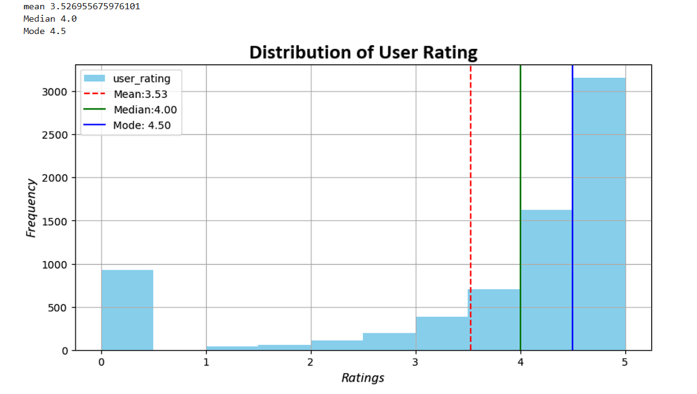
The distribution of user ratings shows that most apps have relatively high ratings, particularly between 4.0 and 5.0. The mean rating is 3.53, while the median is 4.00 and the mode is 4.50. Since the mean is lower than the median and mode, the distribution is negatively skewed. The presence of a considerable number of low-rated apps, including ratings near 0, lowers the overall mean. Overall, users generally tend to give positive ratings to the apps in the dataset.
  - Distribution of Price
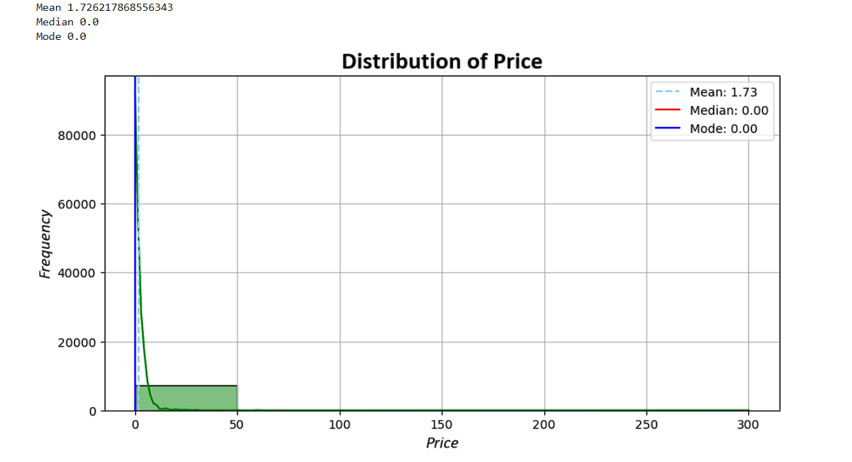
The price distribution shows that most apps in the dataset are free or have very low prices. The mean price is 1.73, while both the median and mode are 0.00, indicating that free apps are the most common. The distribution is highly positively skewed because a small number of apps have considerably higher prices, creating a long right tail. These higher-priced apps increase the mean price above the median. Overall, the results indicate that free apps dominate the dataset, while only a small proportion of apps are relatively expensive.
  - Free Vs Paid Apps
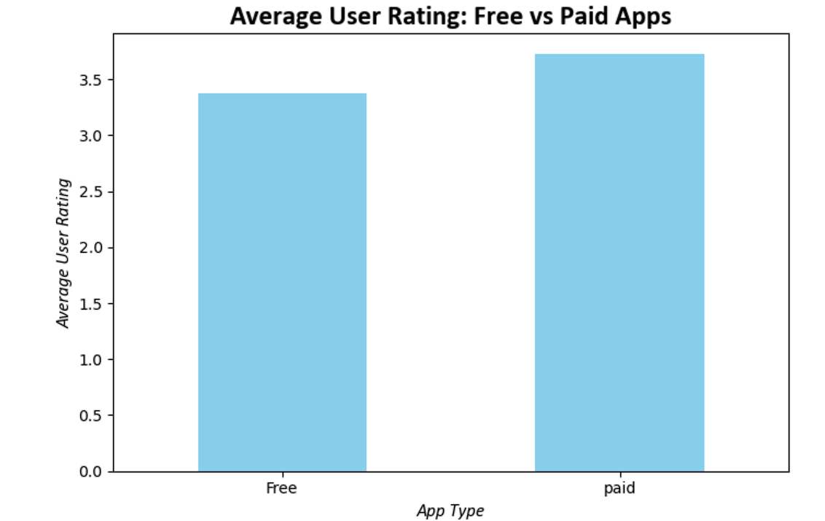
Paid apps have a higher average user rating than free apps, suggesting that users may perceive paid applications as providing greater value or quality. However, rating differences alone do not establish that price causes higher satisfaction.
  - Top 10 Genre by User Ratings
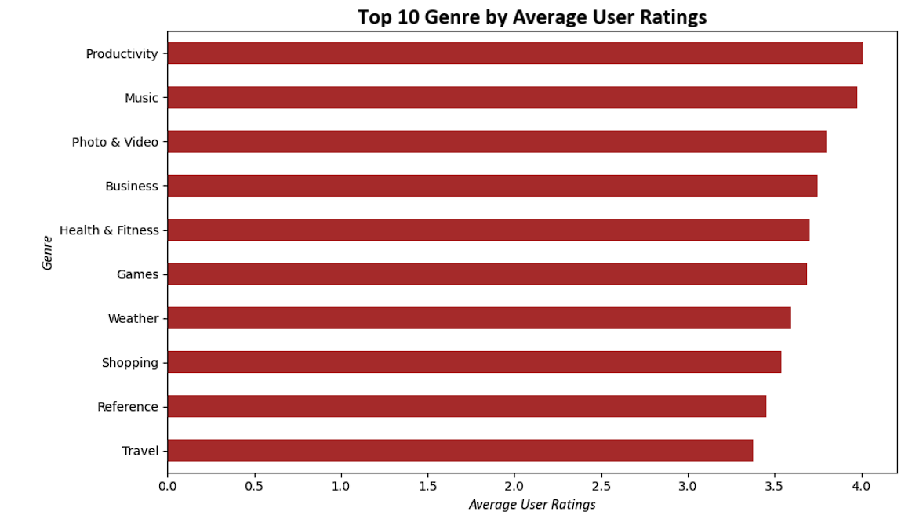
Productivity and Music have the highest average user ratings among the top 10 genres, while Travel has the lowest. This suggests that user satisfaction varies across app categories, with Productivity apps showing the strongest average ratings.
  - App Popularity
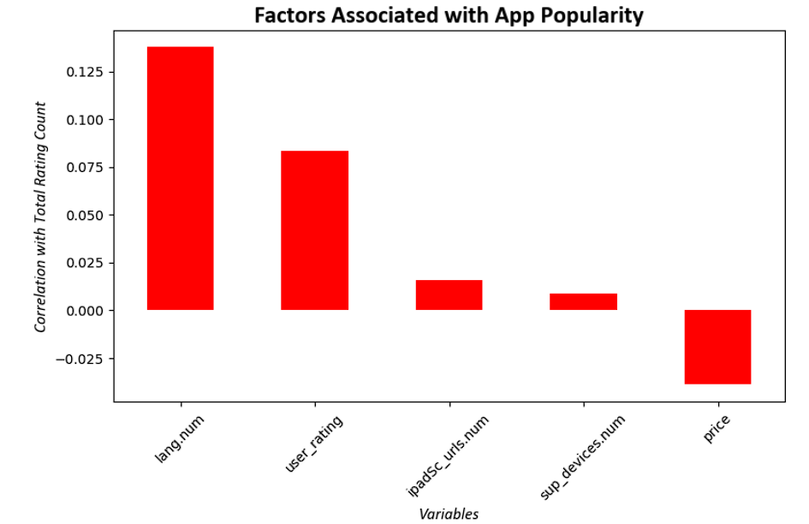
The analysis shows that supported languages have the strongest positive relationship with app popularity, while price has a weak negative relationship. However, all correlations are relatively weak, suggesting that app popularity depends on multiple factors rather than a single variable.
- Probability Distribution
  - Binomial Distribution
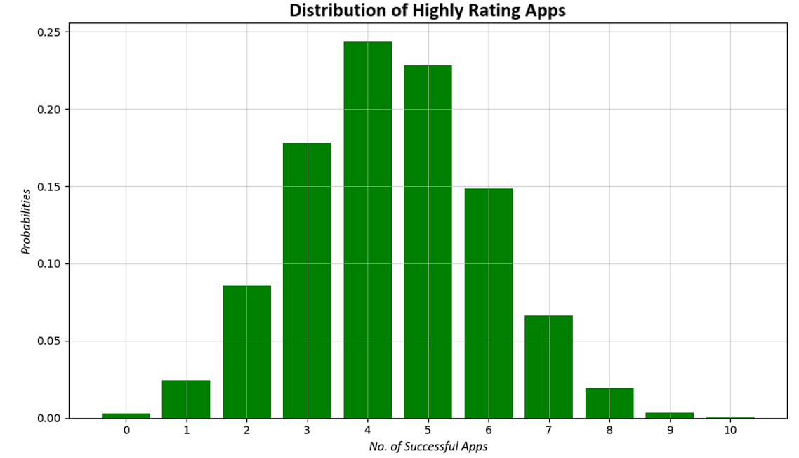
The binomial distribution shows the probability of obtaining different numbers of highly rated apps out of 10 randomly selected apps. The highest probability occurs around the expected number of successful apps based on the calculated success probability. As the number of successes moves farther from this expected value, the probability generally decreases. This analysis provides an estimate of how likely it is to obtain a particular number of highly rated apps in a random sample.
  - Success Vs Failure
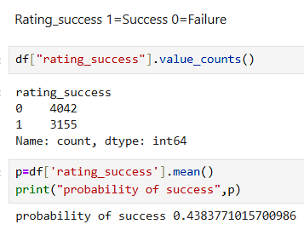
The results show that 4,042 apps (56.16%) were classified as failures because their user ratings were below 4, while 3,155 apps (43.84%) were classified as successful because their ratings were 4 or above. This indicates that highly rated apps represent a smaller proportion of the dataset compared with apps receiving ratings below 4. Therefore, the probability of selecting a highly rated app at random is approximately 0.438 (43.84%), whereas the probability of selecting an app rated below 4 is approximately 0.562 (56.16%).
- Conclusion
This project analyzed Apple App Store data using Python and statistical techniques. The results showed that most apps are free or low-priced, while 43.84% achieved ratings of 4 or above. Productivity and Music had the highest average ratings among the top genres. The analysis also showed that no single factor strongly determines app popularity, while supported devices had very little predictive power for user ratings. Overall, the project demonstrates how Python and statistical analysis can be used to identify meaningful patterns and insights from real-world app data.

